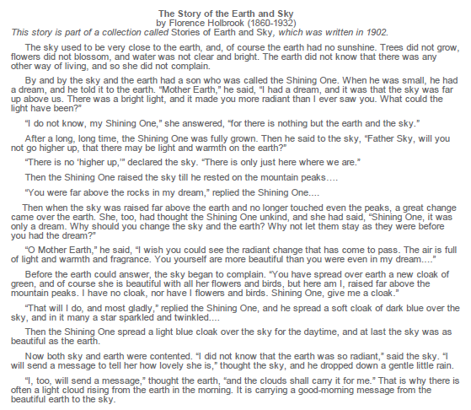
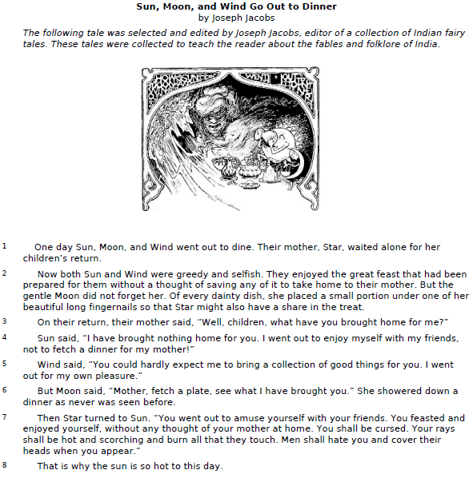
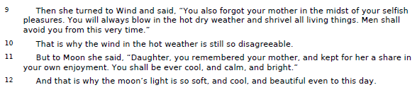

PROMPT
Think about "The Story of the Earth and Sky" and "Sun, Moon, and Wind Go Out to Dinner." Both texts are stories that explain something about the natural world. Explain the major differences between the two stories. Support your answer with examples from the text.

Student A (TRC: S)
Student B (TRC: T)
Student C (TRC: Z)
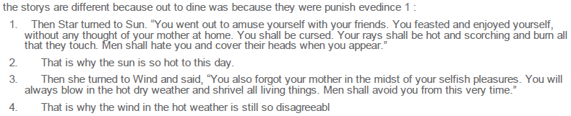
Student D (TRC: W)
Student E (TRC: S)

