July 2015
Fundamentals of Excel PivotTables – Excel 2013
Jessica Joy Morris
Manager of Instructional Data
DC Public Schools

jjmorrisdc@gmail.com

Introduction
Description: In this activity, you will examine a complete PivotTable to identify the major features of a PivotTable before learning how to put a PivotTable together yourself.

- Consider the following table:

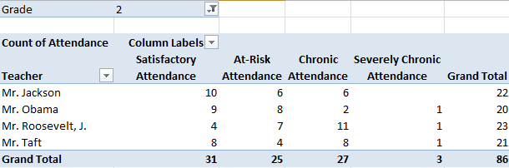

- List all the different parts of the table
- Rows of Teacher Names (Example)

- Write any questions you have about the table

- Summarize what you think the table is showing

- On the tab, point to where you think are the following parts of a PivotTable: “Row Labels”, “Report Filter”, “Column Labels”, and “Values”

PivotTables Overview

What are PivotTables?
PivotTables are the fastest and easiest way to analyze a table of data. They allow you to quickly summarize any data found in the table. They also make it easy to create graphs.

You take a spreadsheet of data:

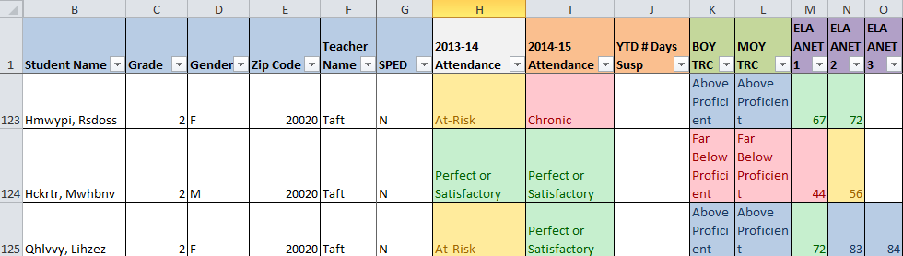

And then use the PivotTable to summarize the data. For example:

Number of entries (students) in the table for each grade | 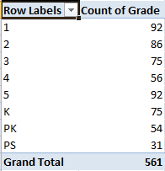
Average ANET 2 Scores for each grade | 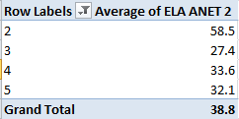
% of Special Education students with each 2nd grade teacher | 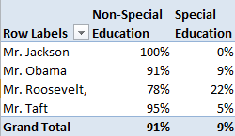

Creating PivotTables

How do I create a PivotTable?

- Open up the “Sample Student Data Report.xlsx” file – this is for a sample elementary school

- Click any cell inside the table that is not blank
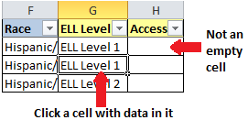

- Select “Insert” from the tabs at the top

- Click on the PivotTable Icon 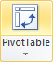

- Select “OK” in the popup that appears
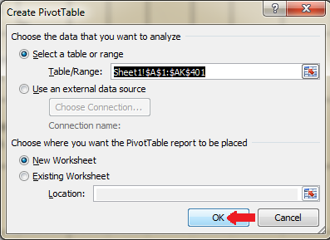

The Parts of a PivotTable
After you insert a PivotTable, you will see this on the right side of your screen:

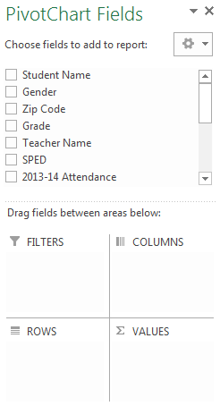 | The PivotTable Field List  This is a list of all the headers in your data table. For the student data report, this would include Grade, Teacher, Attendance, etc.
The Report Filter
Any field you drop in here can be used to limit the data that will be included in your analysis.
- For example, if you only wish to look at data for 2nd graders, drop “Grade” into the Report Filter section and change the filter to “2”
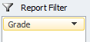
Column Labels
Any field you drop in here will appear as a set of headers
- For example, if you drop “Attendance” into column labels, your pivot table will have a column for each attendance category
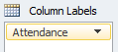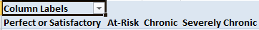
Values
The type of calculation you want to do on the data from a particular field. Types of calculations include average, sum, max, and count
- For example, if you drop “Attendance” into values, it will count the number of students in each attendance category
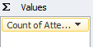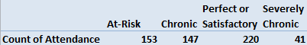
Row Labels
Any field you drop in here will appear as a table of rows.
- For example, if you drop “Teacher” into row labels, a list of each teacher will appear in the rows.
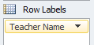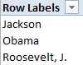

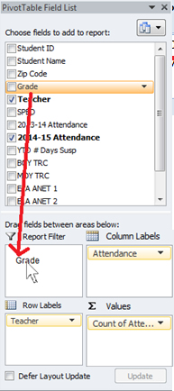
PivotTable Example
Let’s consider an example:
- Drag “Grade” from the field list down into the “Report Filter” box
- Drag “Teacher” from the field list down to the “Column Labels” box
- Drag “Attendance” from the field list down to the “Row Labels” box
- Drag “Attendance” from the field list down to the “Values” box

- In the PivotTable you created, change the “Grade” filter to “2”

- Look at the PivotTable you created
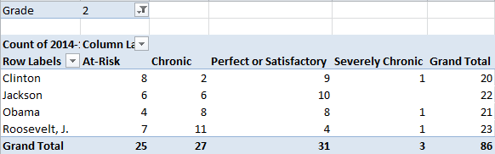 | Now you know  - Jackson had 10 second graders with perfect attendance  - J. Roosevelt had 11 chronic attenders – the highest for all second grade teachers  - There were 31 total second graders with perfect or satisfactory attendance

PRACTICE
A. Identify three other data points in the table and write down what they mean:

B. See if you can go back and create a new PivotTable to show the number of special education (SPED) students of each gender in the school in grades 3-5.

Formatting Your PivotTable

How do I see my data as percentages?
What if you wanted to know the percent of students with chronic attendance in Mr. Jackson’s class?

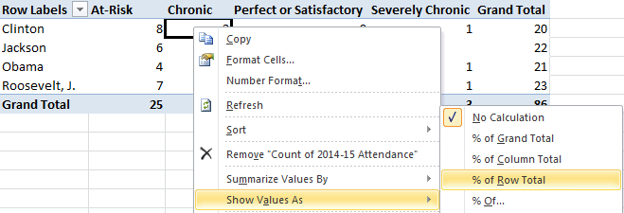
- Right click on any of the values (not the column or row labels) in your PivotTable

- Hover over the option “Show Values As”

- Hover over the option “% of Row Total”

- Now look at your data:

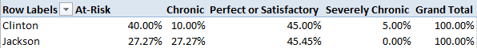 | - 45.45% of Jackson’s students had satisfactory attendance

How do I organize my data?
What if I want to move perfect attendance to be the first column, so the data goes in order from best attendance category (perfect) to worst (severely chronic)?

  - Click on the border around a header and drag the header to a different position
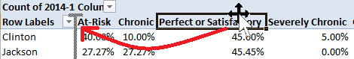

How do I get rid of the decimals in my percentages?
- Right click on any of the values (not the column or row labels) in your PivotTable
- Select “Percentage” as the Category
- Change “Decimal Places” to “0”
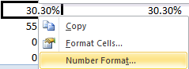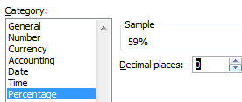

What if I want to see what grade each teacher is in?
You can easily break down your data into categories by including other headers in your row labels. Think of this as creating an outline of data! The way your row labels are organized creates how the outline is organized.

- Drag grade above teacher name in row labels

- Look at the result:
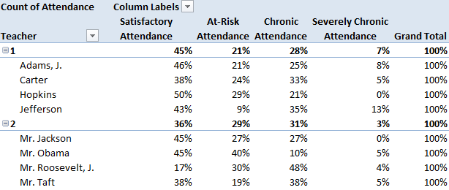

- Note how there is now a list of teachers under each grade

PRACTICE
A. Consider the table you created. Can you identify teachers with the lowest percent of students with satisfactory attendance in grades 1-5?

B. See if you can go back and create a new PivotTable to show the percent of special education (SPED) students from each grade. Move PK, PS, and K to the beginning of the table. See if you can also show gender in each grade.
- What are your Row label(s)?

- What are your Column label(s)?

- What is your Value?

Graphing with PivotTables
Once you have created a PivotTable, creating a graph to share at an ALT meeting, for an ESEA visit, or for a meeting with parents is easy!
- Click anywhere inside the first PivotTable you created

- Select “Insert” from the tabs at the top

- Click on “Column” then select “100% Stacked Column”
- Click on the Graph you created. Then go to the “Analyze” tab. Select “Field Buttons” and click “Hide All”
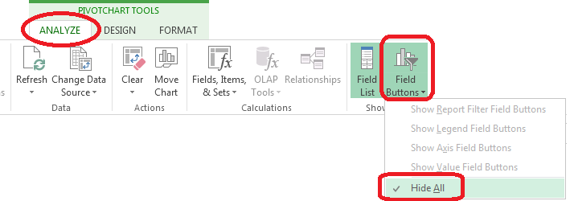
- Click the “+” sign next to the graph. Click the arrow next to “Data Labels” and select “Center”
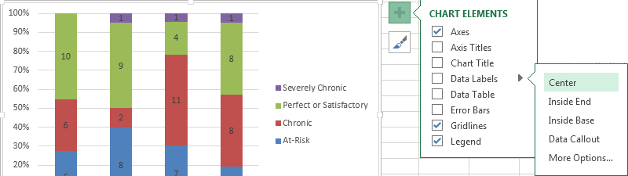

- Click on the “+” sign again and select “Chart Title.” In the field that appears at the top of the graph enter “Second Grade Attendance”

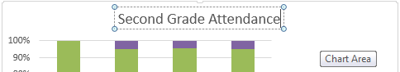

- Click on any of the colored sections of the bars at the top of the graph
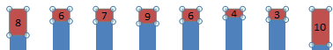
- Select the “Format” tab from the top, find “Shape Fill” and select a color of your choice. Do the same thing to the blue sections of the bars.
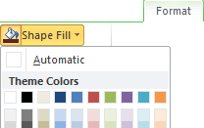
- Celebrate the graph you created!
